## Brief Level Use Cases

### Muhammad Shahan (SP21-BSE-081)

#### Use Case:

#### View Violation:

In this use case, the warden will review the video which is being reported by the citizen. The warden is given the authority to do the following things (use cases).

*Add Violation type:*

When the warden receives the videos. Then the warden reviews the video that if it is a major violation or not. If it is a major violation then the warden assigns it a violation which that driver has broken. If it is not a major violation then the warden does the following.

*Reject complaint:*

If the video does not qualify to be a major violation. Then the warden will reject the video and do the following.

*Send warning:*

After the rejection of the video, the warden would send a warning to the citizen for sending a false video.

Fully Dressed Use Cases

### Muhammad Shahan (SP21-BSE-081)

| Use Case UC1: View Violation |
| --- |
| **Scope**: Review violation  **Level**: Warden’s duty  **Primary** **Actor**: Warden  **Stakeholders and Interests**:  -Warden: Wants to review the violation video received and is in search of an authentic video so that he can issue a challan or reject the video.  **Preconditions**: The video is uploaded. |

**Success Guarantee** (or Post conditions): Video is uploaded by the citizen. The video is reported. The warden reviews the video.

**Main Success Scenario (or Basic Flow):**

1. The citizen uploads a video.
2. The citizen reports the video.
3. The warden receives the video.
4. The warden reviews the video.
5. The video indicates a major violation.
6. The warden approves the video.
7. The warden issues a challan (Fine) to the driver.

**Extensions (or Alternative Flows):**

There is no extension or alternative flow of this use case.

**Special Requirements:**

* The video should be uploaded by the citizen.
* The video should be reported.
* The video should be authentic for being reported as a violation.

**Technology and Data Variations List**:

* Smartphones
* Laptops
* Personal computers
* internet

**Open Issues:**

* What are the limits for a video to be approved by the warden?
* What are the rules of violation?

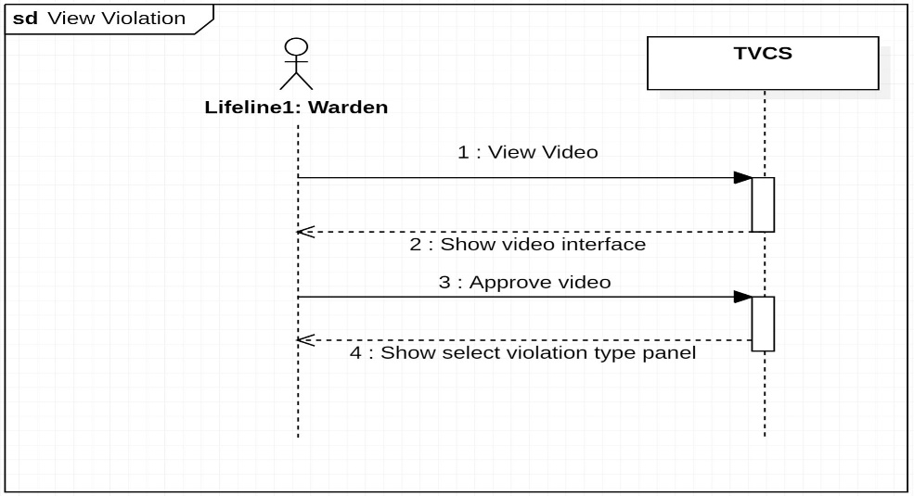**SSD:**

| Use Case UC2: Add Violation type |
| --- |
| **Scope**: Add type  **Level**: Warden’s duty  **Primary** **Actor**: Warden  **Stakeholders and Interests**:  -Warden: Wants to add violation type of the video received as a violation. To refer the user about the violation he has done.  **Preconditions**: The video is uploaded. |

**Success Guarantee** (or Post conditions): Video is uploaded by the citizen. The video is reported. The warden reviews the video. The video indicates a major violation. The warden declares the type of violation.

**Main Success Scenario (or Basic Flow):**

1. The citizen uploads a video.
2. The citizen reports the video.
3. The warden receives the video.
4. The warden reviews the video.
5. The video indicates a major violation.
6. The warden declares a violation type of the video.

**Extensions (or Alternative Flows):**

There is no extension or alternative flow of this use case.

**Special Requirements:**

* The video should be uploaded by the citizen.
* The video should be reported.
* The video should be authentic for being reported as a violation.

**Technology and Data Variations List**:

* Smartphones
* Laptops
* Personal computers
* internet

**Open Issues:**

* What are the limits for a video to be approved by the warden?
* What are the rules of violation?

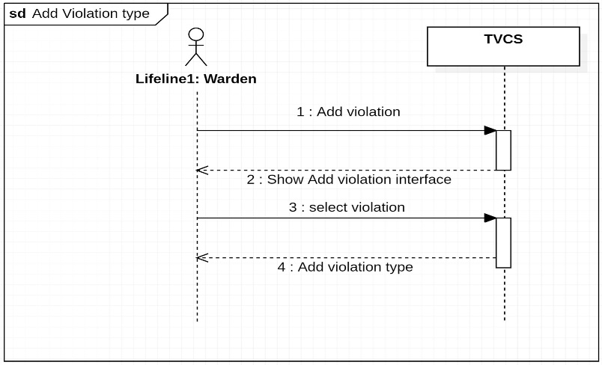**SSD:**

| Use Case UC3: Reject complaint |
| --- |
| **Scope**: Complaint authentication  **Level**: Warden’s duty  **Primary** **Actor**: Warden  **Stakeholders and Interests**:  -Warden: Wants to review the violation video sent by the citizen and authenticate the video whether to reject or accept the video as a violation.  **Preconditions**: The video is uploaded and being compliant. |

**Success Guarantee** (or Post conditions): Video is uploaded by the citizen. The video is reported. The warden reviews the video. The warden rejects the complaint.

**Main Success Scenario (or Basic Flow):**

1. The citizen uploads a video.
2. The citizen reports the video.
3. The warden receives the video.
4. The warden reviews the video.
5. The warden rejects the video.

**Extensions (or Alternative Flows):**

There is no extension or alternative flow of this use case.

**Special Requirements:**

* The video should be uploaded by the citizen.
* The video should be reported.
* The video should be authentic for being reported as a violation.

**Technology and Data Variations List**:

* Smartphones
* Laptops
* Personal computers
* internet

**Open Issues:**

* What are the limits for a video to be approved by the warden?
* What are the rules of violation?

**SSD:**

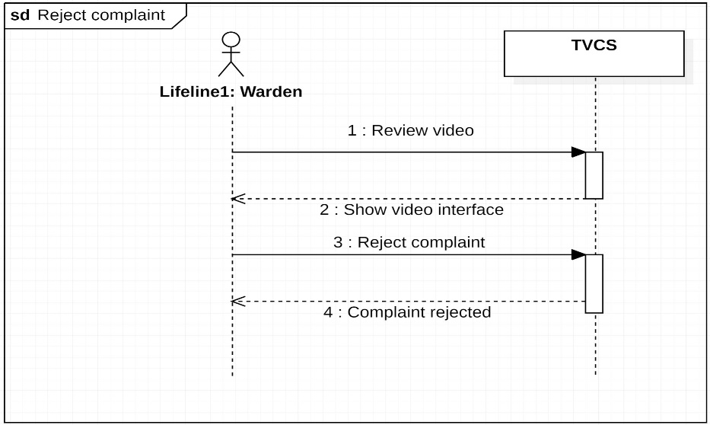

| Use Case UC4: Issue warning |
| --- |
| **Scope**: Send warning notification.  **Level**: Warden’s duty  **Primary** **Actor**: Warden  **Stakeholders and Interests**:  -Warden: Wants to send a warning notification as a warning to the citizen for uploading a false video in which the warden was unable to find a traffic violation and rejected the video to be reported as a violation.  **Preconditions**: The video is uploaded and compliant and the warden did not find the video as a traffic violation. The warden them sends a warning to the citizen. |

**Success Guarantee** (or Post conditions): Video is uploaded by the citizen. The video is reported. The warden reviews the video. The warden rejects the complaint and sends a warning notification to the user.

**Main Success Scenario (or Basic Flow):**

1. The citizen uploads a video.
2. The citizen reports the video.
3. The warden receives the video.
4. The warden reviews the video.
5. The warden rejects the video.
6. The warden sends a warning notification to the citizen.

**Extensions (or Alternative Flows):**

There is no extension or alternative flow of this use case.

**Special Requirements:**

* The video should be uploaded by the citizen.
* The video should be reported.
* The video should be authentic for being reported as a violation.

**Technology and Data Variations List**:

* Smartphones
* Laptops
* Personal computers
* internet

**Open Issues:**

* What are the limits for a video to be approved by the warden?
* What are the rules of violation?

**SSD:**

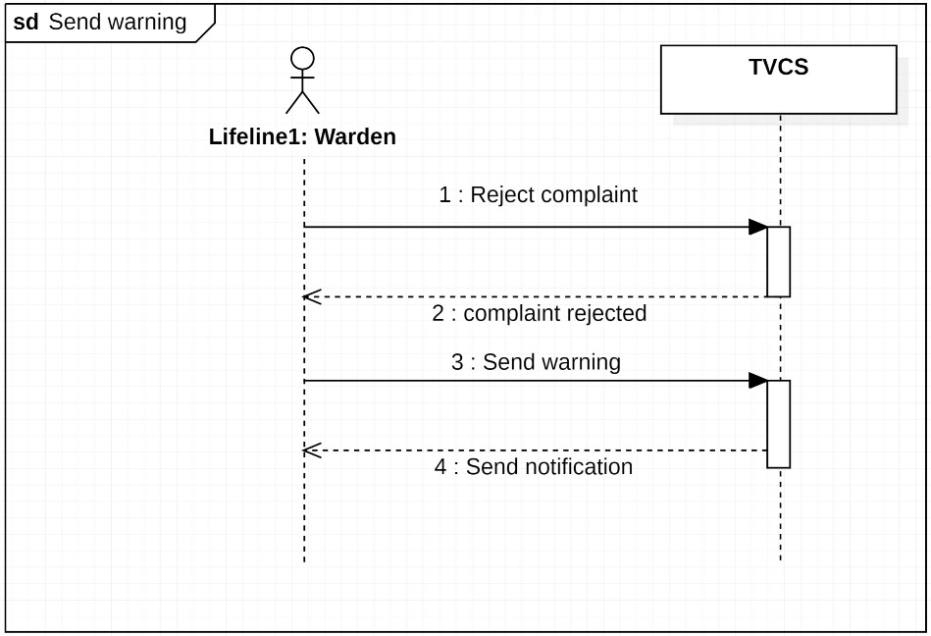

**Screen Shot:**

**GUI:**

